**Instructions to use ImaGIN**

Create a directory with all the DICOM files and the implantation chart of a patient (in this document, we are going to create the directory 0001TEST)

**Installation of Matlab**

Install Matlab, the toolboxes SPM, ImaGIN, Math and Signal in a MATLAB Directory.



Open Matlab

The following window opens.

Change the path to have a direct access to the data patient (1)



**2**

**1**

**Install the toolboxes** (steps to perform only one time)

Click on “Set Path” (2) to install the spm12 toolbox



**4**

**5**

**3**

Click on “Add with Subfolders…” (3) and select the *spm12* directory.

Click on “Save” (34) and “Close” (5).

______________________

**Convert DICOM in NIfTI format**

In the “Command Window” (6), write: *spm fmri* and press “Enter”. Three windows open.



**6**

Click on “DICOM Import” (7)



**7**

In the “Batch Editor” window, fill in where there is “*<-X*”:

* “DICOM files” (8): specify where are the DICOM files to convert
* “Output directory” (9): specify where the NIfTI files will be recorded

Select “DICOM files” and click on “Specify” (10).



**10**

**9**

**8**

Select the directory which contains the DICOM (11) you want to convert (in our example, we will convert the MRIpre for the patient 0001TEST).

Select all the DICOM files with a right-click (12). They will be automatically moved to the selected window (13). Then press “Done” (14).



**12**

**14**

**13**

**11**

Repeat the steps to select the “Output directory” (9).

Once you selected the rights DICOM files to convert (15) and the right output directory (16) (the Output directory is NIfTI in our example), then press “Run Batch” (17).



**15**

**16**

**17**

It will create some .nii files (NIfTI format).

Repeat all the conversion steps from (7) to (17) for every MRI and CT.

**Open the MRI**

To view only one MRI, click on “Display” (18).



**18**

Select the NIfTI file to be posted (19) (NIfTI file having the biggest capacity) and click on “Done” (20).



**20**

**19**

You can modify the color of the MRI (21)



**21**

If you want to visualize all MRI in the same time, click on “Check Reg” (22)



**22**

Select all the NIfTI files of the same patient (23) and click on “Done” (24).



**23**

**24**

Once you can see all the MRI in the same “Graphics” window, you can decide which MRI has the best quality. You can delete the MRI NIfTI files with low quality and rename the other (for examples: 3DT1pre or 3DT1post/CT)

**Match the MRI post/CT on the MRI pre**

Click on “Coregister” and select “Coregister (Est and Res)” (25).



**25**

In the “Batch Editor” window, fill in where there is “*<-X*”:

* “Reference Image” (26): select 3DT1pre, it will be the reference
* “Source Image” (27): select 3DT1post/CT, it will be moved to match to the reference

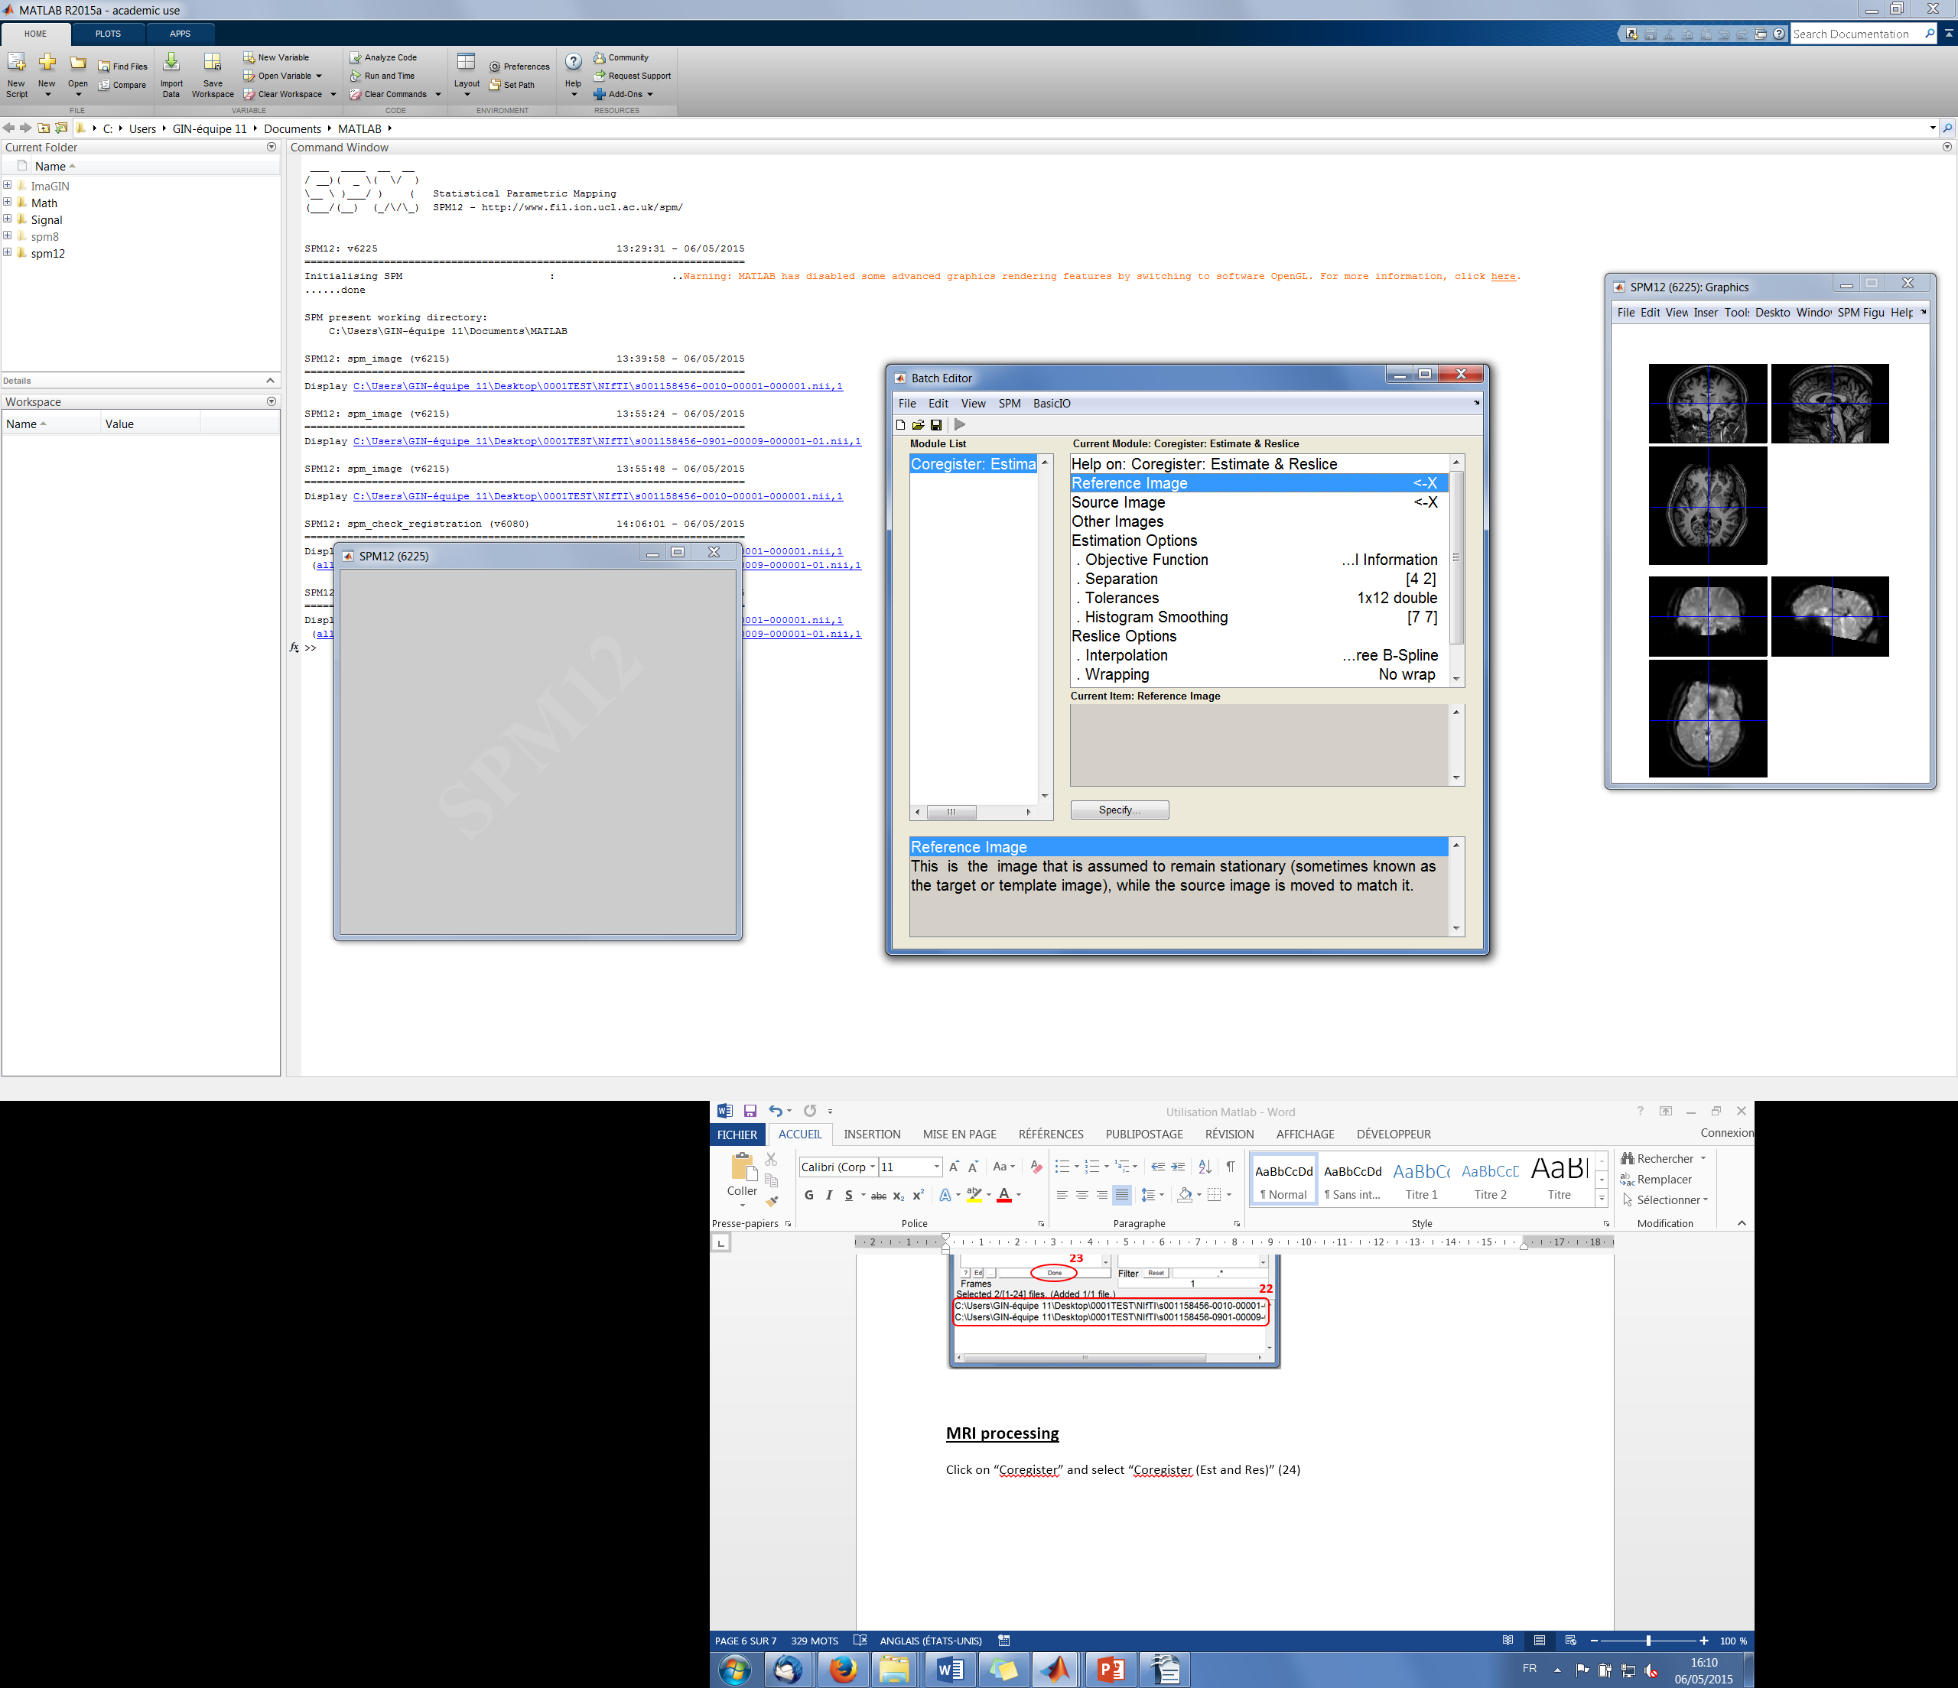

**26**



**27**

Once you selected the right 3DT1pre (28) and the 3DT1post (29)/CT, click on “Run Batch” (30).



**29**



**30**



**3**

**28**



The new rematched 3DT1post/CTt is renamed in “r3DT1post/rCT” and it’s located in the same directory than the NIfTI files.

**If the matching doesn’t work**

If the 3DT1pre and the 3DT1post/CT don’t match after the “Coregister” manipulation, you can do it by hand.

Click on “Display” (31) and select the 3DT1pre.



**31**



Place the cursor on a strategic point you can refind on the 3DT1post/CT and note the 3 coordinates.

In our example, the coordinates are: 1.4 / 14.7 / -1.9 (32).

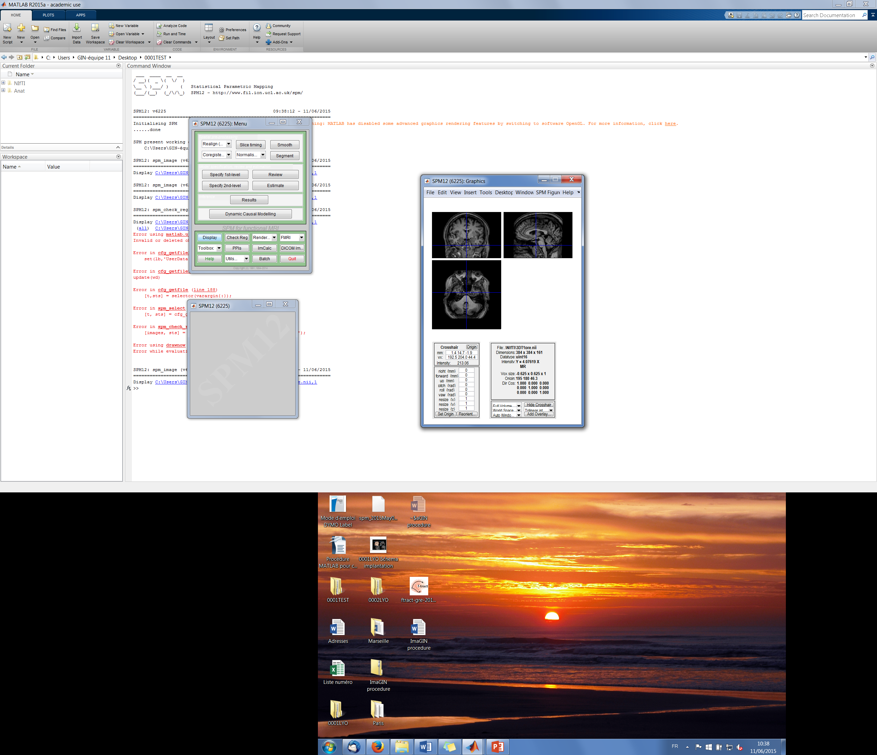

**32**



Open the 3DT1post/CT by clicking on “Display”, find the same point as the 3DT1pre and note the coordinates.

In our example, the coordinates are: 0.9 / 15.9 / -2.0 (33).



**35**

**34**



**333**



Substract the 3DT1pre coordinates to the 3DT1post/CT. Note the result of the 1st coordinate in “right {mm}”, the 2nd coordinate in “forward {mm}” and the 3rd coordinate in “up {mm}”.

In our example, the new coordinates are: 1.4 - 0.9 = **0.5**

14.7 - 15.9 = **-1.2**

-1.9 - -2.0 = **0.1**

Note the new coordinates in the right, forward and up section (34) and click on “Reoriente” (35).

Select 3DT1post/CT, click on “Done” and click on “No” for saving the reorientation matrix for the future reference.

**Localization of the electrodes**

In the “Academic use” window, click on “New script” (36) to write the electrodes coordinates.

Save the document in the patient file (in our example the document’s name is “Electrodes.txt”).

**That’s important to note the extension “.txt” for the document.**



**36**



Open the r3DT1post or the rCT by clicking on “Display”. Open the patient’s implantation chart to have the electrodes’ name.

You can zoom by clicking on “Full Volume” (37).

Place the 3 cursors (38) in the internal extremity of one electrode. Note the letter of the electrode in small letter, in the “Electrodes.txt” document and also note the 3 coordinates (39).

Repeat the steps (38) and (39) with the external extremity of the electrode.

Note the internal and external coordinates for each electrode.



**37**



**39**



**38**



**38**



**38**



Example of an “Electrode.txt” document.



Electrode A

Internal coordinates

External coordinates

Electrode E’

Internal coordinates

External coordinates

Electrode G

Internal coordinates

External coordinates

**Normalisation**

Click on “Normalise (Est & Wri)” (40) to have the normalized coordinates.



**40**



Modify the “Voxel sizes” (41) in [1 1 1].

Specify the data to normalize by clicking twice on “Data” (42).



**42**



**41**



In the “Batch Editor” window, fill in where there is “*<-X*”:

* “Image to Align” (43): select 3DT1pre
* “Image to Write” (44): select 3DT1pre and **r**3DT1post (not the CT)

Click on “Run Batch” (45).



**45**



**44**



**43**



The new normalised 3DT1pre is renamed in “w3DT1pre” and r3DT1post is remaned in “wr3DT1post”. They are located in the same directory than the NIfTI files.

It will create too the y_3DT1pre.

To check the right normalisation, click on “Check Reg” (46).



**46**



Select the w3DT1pre or the wr3DT1post or the both images in the same time AND the avg152T1.nii (MATLAB/spm12/canonical/avg152T1.nii). It will check if the normalised images are well align with the Matlab’s model.

**ImaGIN toolbox**

In the “Command Window” (6), write: *ImaGIN* and press the Enter key.

Click on “Implantation” (47)



**47**



Select “Electrodes.txt” and press “Done”.

Select “y_3DT1pre” and press “Done”

It will create the following files in the same directory as “Electrodes.txt”:

* Electrodes.pts
* Electrodes_MNI.pts
* Electodes_Name
* Electrodes_Pos
* Electrodes_Pos_MNI (it’s the normalized electrodes position)
* Electrodes_Pos_MNI_disp

**Convert the SEEG in SPM file**

Click on “Convert” (48).



**48**



Select the first spontaneous seizure EEG file of the patient (in our example the EEG name is “EEG_1.trc”) and click “Done”.

In the “EEG data conversion setup” window, select atlas “Human” (49).

Select the following parameters:

* Micromed system = “System 4”.
* Create template: click on “Yes” only for the 1st EEG. If this is the 2nd EEG conversion, click on “No”.
* Index of channels to read = write nothing, click on “Enter”
* Reading downsampling = 1
* Name of converted file = Seizure_1
* Select montage = Gre Epi
* Load notes from .TRC? = No
* Select “Electrodes_MNI.pts” and click on “Done”
* Name of montage = “PatientCode” (for example “0001GRE”)
* Number of event types = 0



**49**



It will create:

* Bipole.txt
* EEG_1.hdr
* Seizure _1 (DAT file)
* Seizure _1 (MATLAB Data)

**Select an event**

Click on “Data” (50)



**50**



Select “Seizure_1.mat” and click on “Done” and validate the “Select channels” by clicking only on “Enter”.

Locate the seizure by changing the channels pages (51).



**52**



**51**



Remind the channel number where the seizure is (52). In our example, there is a seizure on the channel n°31.

To locate the time of the seizure’s beginning on the channel n°31, click on “Data” (50), select the “Seizure_1.mat”, click on “Done” and for the “Select channels”, specify the channel where is the seizure. In our example, we specify the channel “31”.

To find the beginning of the seizure on the channel n°31, click on Tools/Zoom In (53) to have a zoom on the time.



**53**



Open a New Script (36) and note the time of the seizure beginning (for example the beginning of the seizure is at 33.2 seconds, so note only 33.2). Save the file and name it “Onset.txt”.

Click on “Event” (54).



**54**



Select the “Seizure_1.mat” file and click on “Done”.

Select the following parameters (55):

* Event = Add
* Number of events to add = 1
* Type of event 1 = Onset
* Select “Onset.txt” and click on “Done”



**55**



To view the pointer of the beginning of the seizure, click on “Event” (54), select “Seizure_1.mat”, click on “Done” and validate the “Select channels” by clicking only on “Enter”.

Click on “Display” (56) to view the pointer at 33.2s in our example.



**56**



Click on “Time zero” (57) to point the beginning of the seizure at time 0 (instead of 33,2 seconds in our example).



**57**



Select the “Seizure_1.mat” file and select the following parameters (58):

* Event of reference = 1
* Duration [sec] before = 0



**58**



Click on “Epoch” (59) to select a baseline. This baseline will be compared to the seizure. We will select 20-30 seconds without any spike before the seizure. In our example, we choose from 15 to 4 seconds before the seizure.



**59**



Select the following parameters:

* Method = Manual
* Select “Seizure_1.mat” and click on “Done”
* Type of start event = Onset
* Duration [sec] before start = 15 (in our example)
* Type of end event = Onset
* Duration [sec] after end = -4 (in our example)
* Prefix of the new file = “Baseline_”

It will create the following files:

* Baseline_Seizure_1 (DAT file)
* Baseline_Seizure_1 (MATLAB file)

*Baseline_Seizure_1.mat could be open by clicking on “Data”.*

In the Analysis part, click on “Compute” (60).



**60**



Select “Seizure_1.mat” and click on “Done” and “Enter”.

Select the following parameters (61):

* Prefix of new file = click on Enter
* Time Frequency decomposition = Multitaper
* Frequencies (Hz) = 1:120
* Factor of modulation = 7
* Time window width [sec] = 1
* Time window of analysis [sec] = -15 10 (in our example)
* Time resolution = 0.1 (in our example)
* Taper = Hanning
* Select channels = click on Enter





**61**



It will create:

* M1_Seizure_1 (DAT file)
* M1_Seizure_1 (Matlab Data)

Select “Normalise” (62).



**62**



Select “m1_seizure_1.mat” and click on “Done”.

Click again on “Done” without select a file and write the following parameter:

* Baseline time window (s) = -15 -1 (in our example) (63)



**63**



It will create:

* nm1_Seisure_1 (DAT file)
* nm1_Seizure_1 (Matlab Data)

Click on “Time Frequency” (64).



**64**



Select “nm1_Seizure_1.mat” and click on “Done” to view the seizure’s time frequency (65).

To change the channel, click on the Channel cursor” (66)



**66**



**65**



For each EEG’s seizure, repeat the steps from (50) to (66).

**Create the epileptogenicity map**

Click on “Epileptogenicity” (67).



**67**

Select “Seizure_1.mat” file and click on “Done”. For a group analyze, select all the same type of seizure files.

Select “Baseline_Seizure_1.mat” ad click on “Done” and select the following parameters (68):

* Peri-onset time [s] = 0:1:3 (it means 1 picture every second during 3 seconds).
* Select atlas = Human
* Frequency Band [Hz] = 100 120 (it could be change)
* Use cortical mesh = Yes
* Select “w3DT1pre.nii” file and click on “Done”
* Mesoscopic time scale [s] = 2 (for a little seizure)
* Time resolution [s] = 0.1 (could be changed)
* Propagation threshold = 0.05
* AR correction = Yes (allow the correlation)
* File name = click on “Enter” or name the type of the seizure.
* Bad channels = 0 if there isn’t any bad channel or give the number of the bad channel.

 It will create the “SPM_EI_Seizure” directory.

**68**

PARTIE A TERMINER

Click on “Results” (69)



**69**

In the “SPM_EI_Seizure” directory, select “spm.mat” file and click on “Done”.

Click on {1} and “Done”

Select the following parameters

* None
* FEW
* 0,05
* 0
* 2D/3D

(spm Figure… Color Grey jet)

Click on “Overlay” (70), “Section” (), select “w3DT1” file and click on “Done”.



**70**

Click with the right button on the picture and select “Go to global maximum”.

Click on “Brain Overlay” () and select the following parameters:

* No
* Select “SpmT_0001” file in the “SPM_EI_Seizure” directory and click on “Done”
* No
* No
* Yes (for the electrodes)
* Select “Electodes_Pos_MNI_disp” file
* 3,5 (value of the previous pictures)
* -10 (the value of the previous pictures)
* No
* Human
* b
* Select “w3DT1” file and click on “Done”.

Click with the right button on the picture and select “Go to global maximum”.

SPM Figure

Save “Figure as…” and you can name the file “Results.ps” in the patient directory.

To open the “Resultas.ps” file, you need “Gost view” and “Gost script” (free download).

Open the “Results.ps” and “File/export as pdf”. Save the file in pdf.

Click on “Brain overlay” () and select the “Delay” file in the “SPM_EI_Seizure” directory.



SPM Figure

Save “Figure as…” and you can name the file “Delay.ps” in the patient directory.

Open the “Delay.ps” and “File/export as pdf”. Save the file in pdf.